

Distribution Statement

DISTRIBUTION STATEMENT A. Approved for public release. Distribution is unlimited.

This material is based upon work supported by the CDC under Air Force Contract No. FA8702-15-D-0001. Any opinions, findings, conclusions or recommendations expressed in this material are those of the author(s) and do not necessarily reflect the views of the CDC. Reasonable efforts have been made to present accurate and reliable information. The user, however, assumes responsibility for the consequences of using this information. Neither the Centers for Disease Control and Prevention, nor any of their employees, make any warranty, express or implied, or assume any legal responsibility for the accuracy or completeness of the information and instructions contained on this website and the SimAEN software. Use of specific trade names and commercial sources does not constitute an endorsement by the authors or by the Centers for Disease Control and Prevention.

© 2021 Massachusetts Institute of Technology.

Delivered to the U.S. Government with Unlimited Rights, as defined in DFARS Part 252.227-7013 or 7014 (Feb 2014). Notwithstanding any copyright notice, U.S. Government rights in this work are defined by DFARS 252.227-7013 or DFARS 252.227-7014 as detailed above. Use of this work other than as specifically authorized by the U.S. Government may violate any copyrights that exist in this work.

Author:

Richard C. Gervin, Jr.   
Group 21 HADR Systems

Contents

Distribution Statement 1

About Simulated Automated Exposure Notification (SimAEN) 3

Design 3

Accessing the SimAEN Web Application 3

SimAEN Landing Page 4

Helpful Hints About the Site 4

Model Details 4

Frequently Asked Questions (FAQ) 5

Tool Tips 5

Getting Started 6

SimAEN Web Application 6

Input Parameters & Changing Parameters 7

Analysis Quick Look 8

Cumulative 8

Cumulative by Day 8

Breakdown by Day 9

Compare Model Runs 9

Comparison Page 10

Glossary 12

# About Simulated Automated Exposure Notification (SimAEN)

Massachusetts Institute of Technology Lincoln Laboratory (MIT LL) has developed Simulated Automated Exposure Notification (SimAEN): a free, publicly available, online tool to help state and local public health planners and decision makers explore the trade-offs between different non-pharmaceutical interventions (NPIs), such as Exposure Notification (EN), and the most effective ways to align and integrate them to combat the spread of COVID. SimAEN aims to help public health professionals quickly answer questions about workflows, policies, and resource impacts to guide decision-making in the face of evolving circumstances.

In an epidemic, the speed and breadth of disease spread can be reduced by isolating infected individuals to prevent further spread to others. The severity of the COVID-19 pandemic challenges public health departments and community members to employ not one “perfect” mitigation strategy, but a combination of several imperfect ones: the “Swiss cheese approach”. Different community conditions (vaccination levels, mask wearing, and contact tracing resources) may predispose regions to different levels of success in limiting the spread of disease. The effect of novel non-pharmaceutical interventions (NPIs), such as automated contact tracing tools, is an area of active research. The SimAEN tool was designed to model how different strategies, including the globally available Bluetooth-based Exposure Notification (EN) service, may affect the overall disease prevalence in a population.

## Design

The tool uses agent-based modeling to “play out” a number of scenarios, based on the initial conditions and probabilities selected by the user. It incorporates key metrics from our research on Exposure Notifications, including Bluetooth Low Energy signal measurements and representative contact models. SimAEN outputs have been tuned to match U.S. and European COVID-19 case data to provide the most accurate predictions available. It predicts the number of infections, quarantines, public health calls, and tests over a 30-day period, which will have a direct impact on public health resources in a region. Users can compare model outputs from up to two runs, or download model parameters and outputs to produce more complex visualizations using their preferred software. The tool enables public health professionals and decision makers to explore critical transition points where interventions become effective.

## Accessing the SimAEN Web Application

The SimAEN web application can be found at <https://simaen.philab.cdc.gov>.

If prompted to enter a user name and password, and you have not been provided one, contact the SimAEN team at [SimAEN@ll.mit.edu](mailto:simAEN@ll.mit.edu).

# SimAEN Landing Page

The SimAEN landing page provides basic information about the SimAEN web application, what features are available to SimAEN users, and links to other documents about the Exposure Notification Service.



Helpful Hints About the Site

## Model Details

The Model Details section describes key assumptions made by the SimAEN model, with regard to disease transmission characteristics, person-to-person interactions, and close contact definitions. It outlines the workflow of traditional contact tracing prevalent at the time of implementation, as well as contact tracing augmented with Automated Exposure Notification. An overview of the relationships between model inputs and outputs is provided, along with technical references.

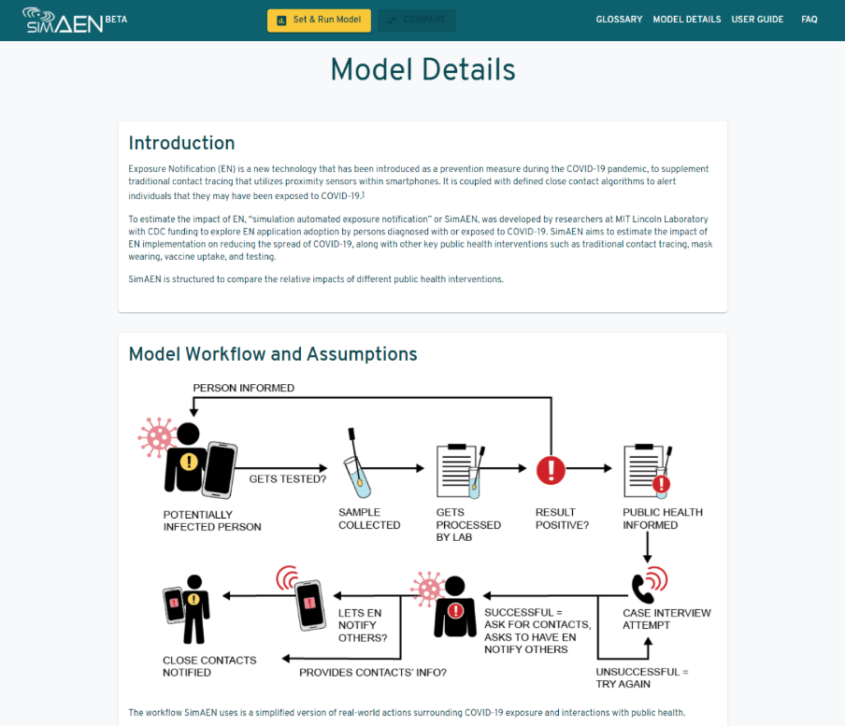

## Frequently Asked Questions (FAQ)

The FAQ page of the website is a list of questions and answers to the most frequently asked questions.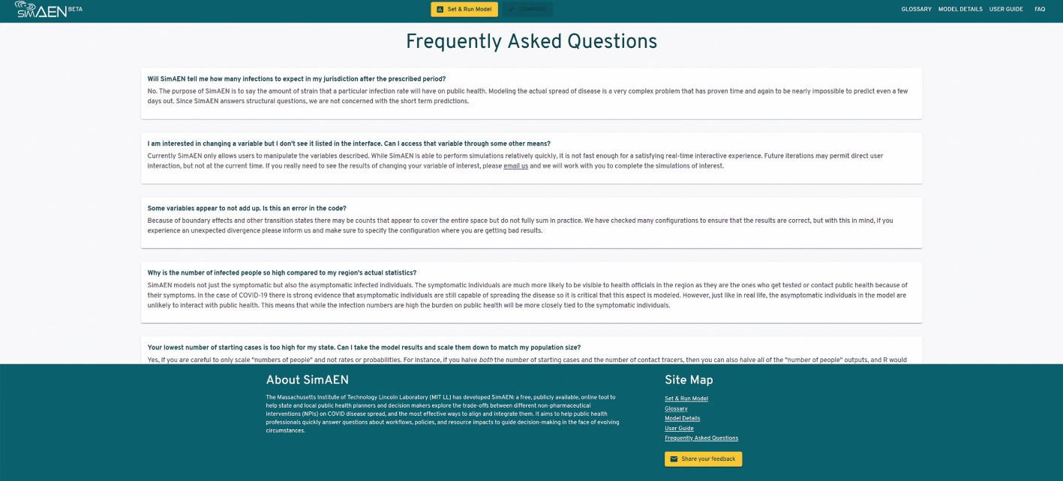

## Tool Tips

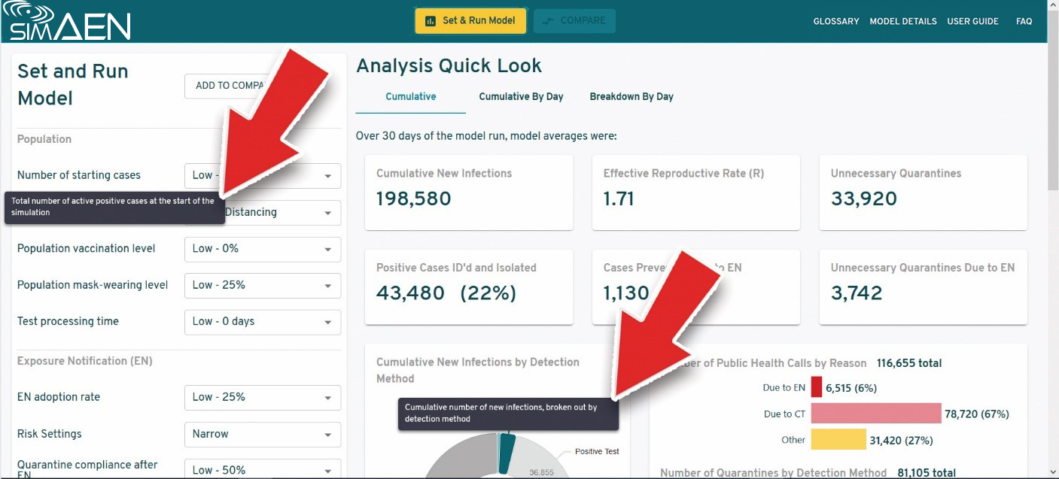You can mouse over any of the parameters or section headers to bring up tool tips providing more information about each parameter and the data in each section header.

# Getting Started

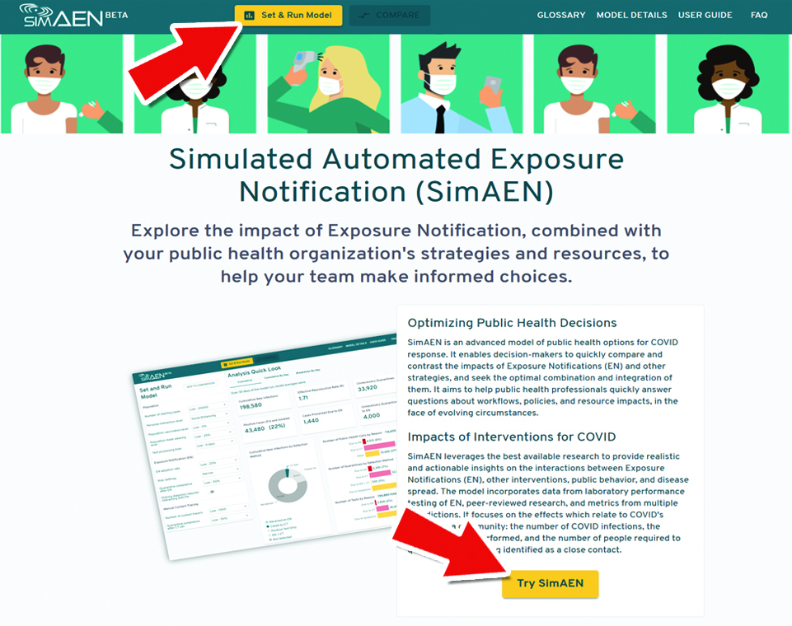To begin setting parameters and running the model, select the **Set & Run Model** button in the top navigation bar, or select any button marked **Try It**.

# SimAEN Web Application

|  |  |  |
| --- | --- | --- |
| 1. | SimAEN Main Site Navigation | Navigate between pages of the SimAEN website, access the web app, get more details on the SimAEN model, or read through frequently ask questions. |
| 2. | Model Input Parameters | The input parameters are broken down into 3 sections, Population, Exposure Notification (EN), and Manual Contact Tracing (MCT) and can be adjusted to change the outcome of each run. |
| 3. | Data Visualization Options | Data from each run can be viewed as Cumulative, Cumulative by day, and Breakdown by day. |
| 4. | Model Run Output Data |  |

## Input Parameters & Changing Parameters

Over 60 input parameters are working behind the scenes of the model and are not adjustable, but there are eleven parameters on the web application that can be adjusted to produce different outcomes. These parameters are arranged into 3 sections and open with a set of default values. The three categories of parameters are:

* Population

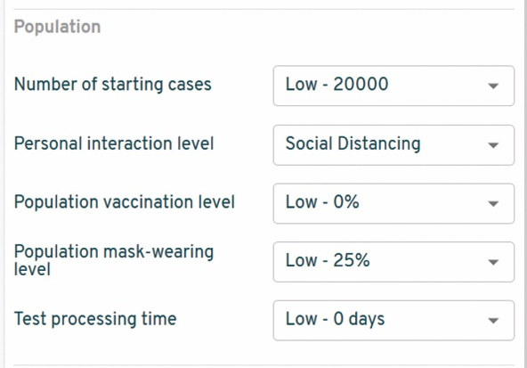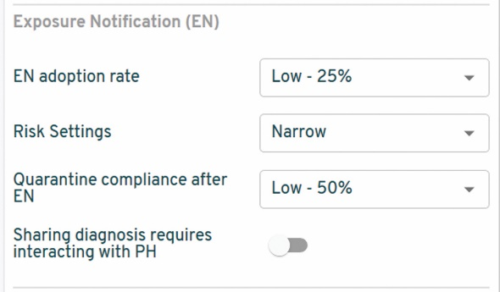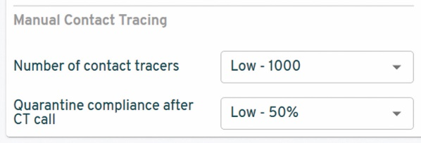

* Exposure Notification
* Traditional Contact Tracing

You can change as many or as few of the parameters as you would like, by simply selecting the dropdown buttons next to the parameter/parameters you would like to change. A dropdown box will open with a list of predefined set of data to use for the model run. Select the value you wish to use.

When a parameter in the Set and Run Model section is changed the Analysis Quick Look will automatically update.

For transparency, the “fixed” model parameters are listed in a collapsible panel beneath the adjustable parameters.

# Analysis Quick Look

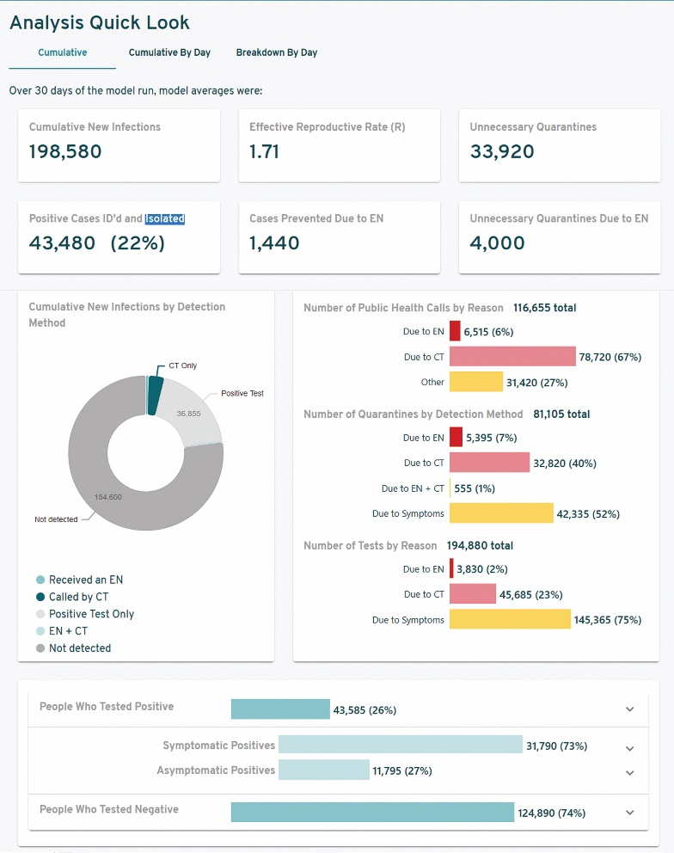When the SimAEN application first opens, the default data will populate in the Analysis Quick Look section on the right-hand side of the page. Each run of the model to include the default settings spans a 30 day window.

Data from each run can be viewed in 3 different tabs:

* Cumulative
* Cumulative by day
* Breakdown by day

Each card containing data and/or charts has header text providing a basic description of the data in that card. If you need more information about any of the cards you can mouse over the header text and tool tips will pop-up with more information. You can also navigate to the glossary page of the website and look up the term you need more info on.

## Cumulative

The cumulative view provides the most data for each model run. Each number shown represents totals at the end of 30 simulated days of agent interactions, averaged across 20 model runs to smooth out variation. The proper interpretation would read (for instance) “By the end of the 30 day model run, 3,830 total tests were taken due to an Exposure Notification”.

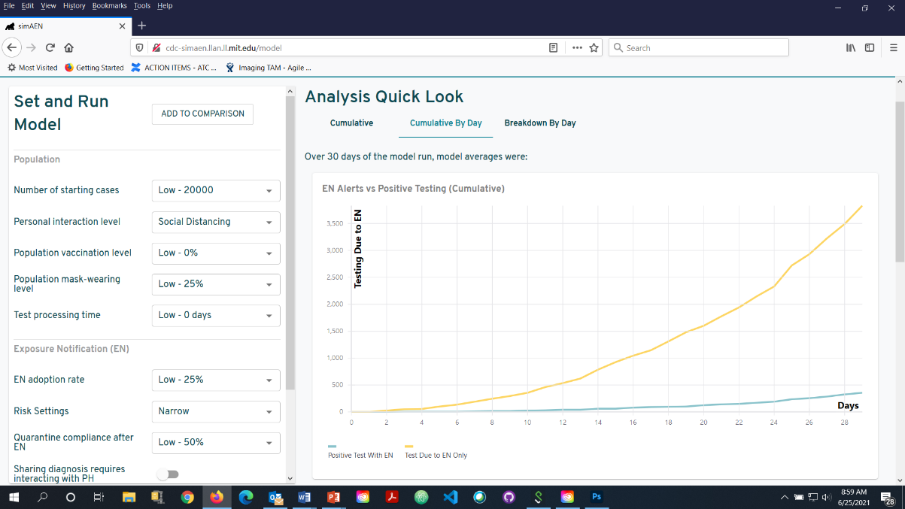

## Cumulative by Day

Each chart displays the cumulative averages on each day of the model run, adding each day’s total to the next, to show growth over time. The totals on day 30 match the totals displayed in metrics under the Cumulative tab. The proper interpretation at each day would read (for instance) “By Day 4, 55 total tests were taken due to an Exposure Notification”.

## Breakdown by Day

Each chart displays the total (averaged over model runs) on each day of the 30-day model run to show day-to-day variations. Adding the totals on each day will result in the numbers show under the Cumulative and Cumulative By Day tables. The proper interpretation at each day would read (for instance) “On Day 4, 5 tests were taken due to an Exposure Notification”.

# Compare Model Runs

SimAEN allows the user to store up to two model runs for comparison. To store and compare model runs:

1. 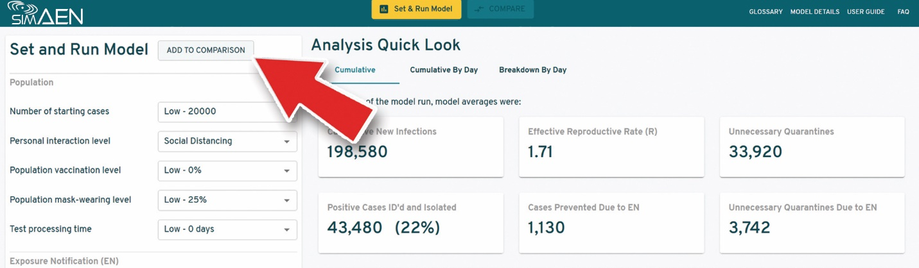Select the Add to Comparison button at the top of the Set and Run Model panel. (This will add the model run to the compare page.)
2. Enter the model parameters for your second run.
3. Click the Add to Comparison button again.

The Compare button in the top menu bar will change to a yellow color indicating your comparison is ready for viewing.

1. 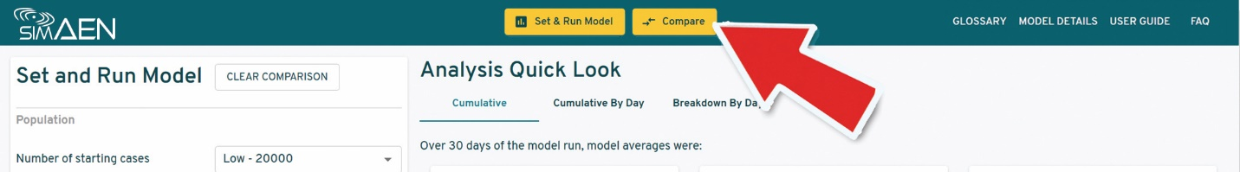Select the Compare button to open the model run comparison.

Note: you can only compare two model runs at a time.

# Comparison Page

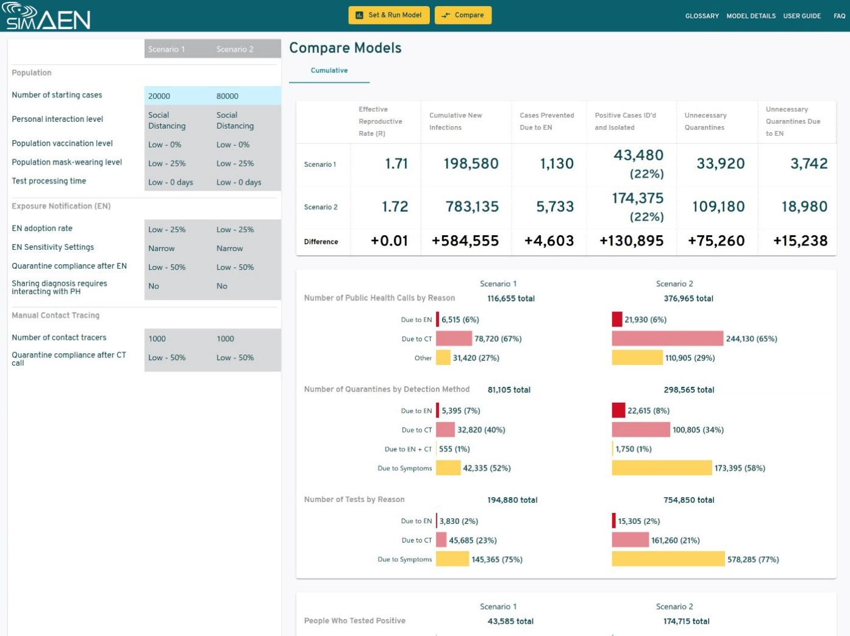The compare page will load the data from both model runs side by side, allowing you to easily understand the differences between each model run.

If you wish to run another comparison

1. Select the Run and Set Model button in the top navigation bar. This will bring you back to the main page.

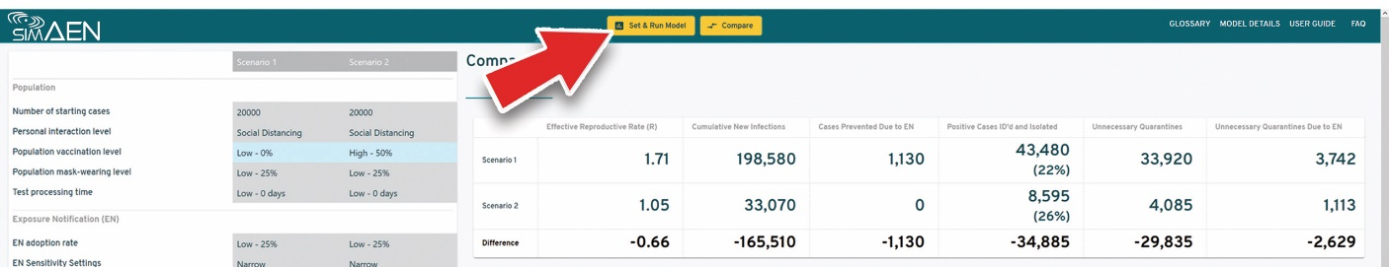

1. Select the Clear Comparison button at the top of the model parameters section of the page.

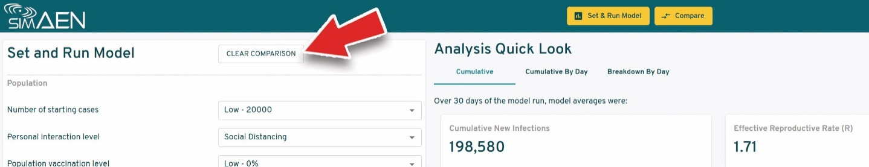

The two previous model runs are now cleared. The yellow Compare button in the top navigation bar will grey out, indicating there are no stored model runs.

1. Repeat the steps from the Changing Parameters section of this manual.

# Glossary

|  |  |
| --- | --- |
| **Model Outputs** | **Detailed Description** |
| Effective Reproductive Number (R) | Average number of secondary cases per infectious case in a population made up of both susceptible and non-susceptible hosts |
| Positive Cases ID’d and Isolated | Number of positive cases that were detected and adhered with the isolation requirement |
| Cases Prevented due to EN | Number of estimated new infection cases that were averted due to the improved earlier detection by EN and the reduction of consequent infections due to infected persons isolating |
| Unnecessary Quarantines | Individuals who are not infected but entered quarantine as a result of EN or traditional contact tracing (CT) |
| Cumulative New Infections by Detection Method | Cumulative number of new infections identified, broken out by detection method |
| Received an EN | EN received was the only reason for the test |
| Called by CT | Traditional CT call was the only reason for the test |
| EN + CT | Test was triggered by both EN and CT call |
| Positive Test Only | Test was triggered by another reason, such as symptoms |
| Not detected | Infections which were not detected, i.e., no test conducted |
| Number of Public Health (PH) Calls by Reason | Cumulative number of new PH calls, broken out by reason |
| Due to EN | Calls from people to PH because they received an Exposure Notification |
| Due to CT | Calls from PH to people who were identified through contact tracing |
| Other | Calls from people to PH after receiving a positive test, including to obtain key |
| Number of Quarantines by Detection Method | Cumulative number of people adhering to quarantine guidelines, broken out by detection method |
| Due to EN | EN was the only reason for quarantine |
| Due to CT | Traditional CT was the only reason for quarantine |
| EN + CT | Quarantine was triggered by both EN and CT call |
| Due to Symptoms | Symptoms were the reason for quarantine |
| Number of Tests by Reason | Cumulative number of new tests, broken out by reason |
| Due to EN | EN was the reason for the test |
| Due to CT | CT notification was the reason for the test |
| Due to Symptoms | Symptoms were the reason for the test |
| People who tested positive | Cumulative number of people who tested positive, including possibly multiple positive tests per person |
| Symptomatic Positives | Cumulative number of people who tested positive and were symptomatic |
| Asymptomatic Positives | Cumulative number of people who tested positive and were asymptomatic |
| People who Tested Negative | Cumulative number of people who tested negative, including possibly multiple negative tests per person |

|  |  |
| --- | --- |
| **Variable Model Parameters** | **Detailed Description** |
| Number of Starting Cases | Total number of active positive cases at the starting date of the period |
| Personal Interaction Level | Extent to which people interact with others in the model population, each day |
| Population Vaccination Level | Percentage of people who received full or partial vaccination |
| Population Mask-Wearing Level | Percentage of people who wear masks in indoor or outdoor settings |
| Test Processing Time | Duration between the time a test is taken to the time results are received |
| EN Adoption Rate | Percentage of people that installed and are using the EN service |
| Risk Settings | Level of EN sensitivity/specificity that is configured for the population |
| Quarantine Compliance After EN | Percentage of people adhering to the guidelines to enter quarantine when receiving an EN |
| Sharing Diagnosis Requires Interaction with Public Health (true/false) | If checked, sharing diagnosis through EN requires receiving a one-time code from public health (PH); some regions issue codes automatically via SMS. (Directly affects “Number of calls” model output) |
| Number of Contact Tracers | Number of contract tracers deployed to perform contact tracing (CT) activities in the region |
| Quarantine Compliance After CT call | Percentage of people adhering to the guidelines to enter quarantine when receiving a CT call |

|  |  |
| --- | --- |
| **Fixed Model Parameters** | **Detailed Description** |
| End Day | Number of days that the simulation lasts |
| Max Current Cases | Maximum number of current cases before program stops |
| Mean Latent Period | The mean time between an individual being exposed and becoming infectious |
| Latent Period Standard Deviation | The standard deviation of latent period |
| Mean Incubation Period | The mean time between an individual being exposed and becoming clinical |
| Incubation Period Standard Deviation | The standard deviation of incubation period |
| Recovery Length | Number of days it takes to be sure of recovery from infection |
| Asymptomatic Rate | The likelihood an infected person will be asymptomatic |
| Asymptomatic Transmission Rate (No Mask) | The probability that a true contact event involving an asymptomatic infected person will result in infection |
| Pre-symptomatic Transmission Rate (No Mask) | The probability that a true contact event involving a pre-symptomatic infected person will result in infection |
| Symptomatic Transmission Rate (No Mask) | The probability that a true contact event involving a symptomatic infected person will result in infection |
| Testing Rate With Call | The probability that a person who has been called by public health will get tested on any given day |
| Baseline Testing Rate | The probability that a person who has no symptoms and has not been notified in any way will get a test |
| Testing Rate With EN | The probability that a person who has received a notification through the app will get tested on any given day |
| Testing Rate With Symptoms | The probability that a person who is symptomatic will get tested on any given day |
| Testing Delay Standard Deviation | The standard deviation of number of days that it takes for a test to get back (normal distribution) |
| Daily Test Capacity | The maximum number of tests that can be given in a day |
| Positivity Rate With Exposure | The probability that a person who has been exposed will test positive |
| Pre-symptomatic Positivity Rate | The probability that someone who is pre-symptomatic will test positive |
| Symptomatic Positivity Rate | The probability that someone who is symptomatic will test positive |
| Asymptomatic Positivity Rate | The probability that someone who is asymptomatic will test positive |
| Key Upload Rate With Positivity | The probability that a person who is running the app who gets a positive test will upload their key to public health |
| Successful Call (Unanticipated) | The probability that a call from public health will reach a person identified through contact tracing |
| Successful Call (Anticipated) | The probability that a call from public health will reach a person expecting the call |
| Contact Tracing Identification Rate | The probability that an individual will be found using manual contact tracing |
| Max Contacts Recalled | The maximum number of people an agent can recall through manual contact tracing on a single phone call |
| Work Day Length | The number of hours each contact tracer can spend on calling |
| Max Call Attempts | The number of time PH will try to contact an individual before giving up |
| Missed Call Time | The length of time that a missed call takes |
| Index Case Call Time | The length of time that a contact tracer takes to perform contact tracing on an index case by phone call |
| Close Contact Alert Call Time | The length of time that a contact tracer takes to notify a close contact by phone call |
| EN Key Upload Call Time | The length of time it takes for a call to obtain code for key upload |
| Start Maximal Rate | Probability that an individual from the initial batch of infected individuals will start in the maximal Restriction state |
| Maximal Restriction Mask Rate | The probability that a person will wear a mask while they are in the maximal restriction state |
| Mask Effectiveness | Extent to which transmission rates are proportionally reduced for each person wearing a mask (higher numbers mean lower transmission risk) |
| Public Health Call Rate After Positive | The probability that a person will call public health after a positive test |
| Public Health Call Rate After EN | The probability that a person will call public health after receiving an EN notification |
| Mean New Cases Maximal | The average number of contacts that an individual encounters each day after entering self-isolation |
| New Cases Standard Deviation Maximal | The standard deviation of contacts that an individual encounters each day after entering self-isolation |
| Starting Behavior Return Rate | Probability of returning to starting behavior given negative test result and no symptoms |
| Maximal Restriction Rate Given Symptomatic | Probabilities associated with entering maximal level of restricted movement given the person is symptomatic |
| Maximal Restriction Rate Given Positive Test | Probabilities associated with entering maximal level of restricted movement given the person receives a positive test |
| Maximal Restriction Rate Given PH Call | Probabilities associated with entering maximal level of restricted movement given the person is successfully called by PH |
| Maximal Restriction Rate Given EN | Probabilities associated with entering maximal level of restricted movement given the person is notified by EN |
| Vaccinated Can Spread Asymptomatically | Whether vaccinated individuals who are carriers of the disease are asymptomatic but still able to spread the disease |